PRACTICAL NO. 09
AIM: To connect a Java application with Amazon Simple Workflow Service (SWF) using AWS SDK and retrieve registered workflow domains.
Step 1: AWS Console Login
- Open browser
- Go to: https://aws.amazon.com/console/
- Login using Root user
- After login then search IAM
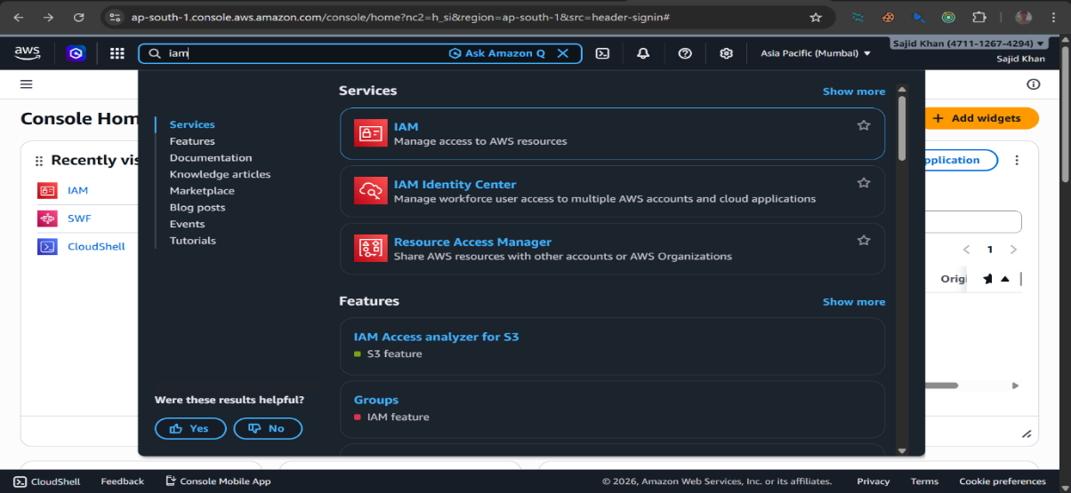
Step 2: Create IAM User
- Go to IAM
- Click Users
- Click Create User
- Enter user name: aws-java-user
- Click Next
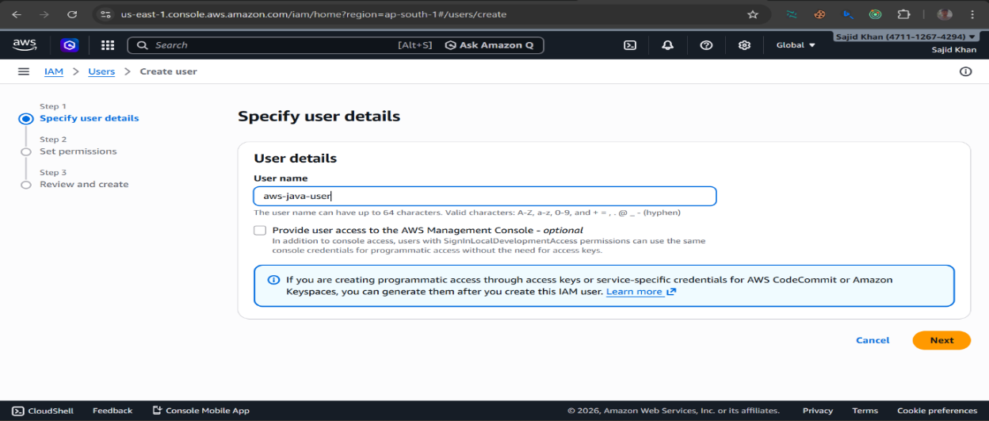
Step 3: Set Permissions
- Select Attach policies directly
- Search: AdministratorAccess
- Select the policy
- Click Next
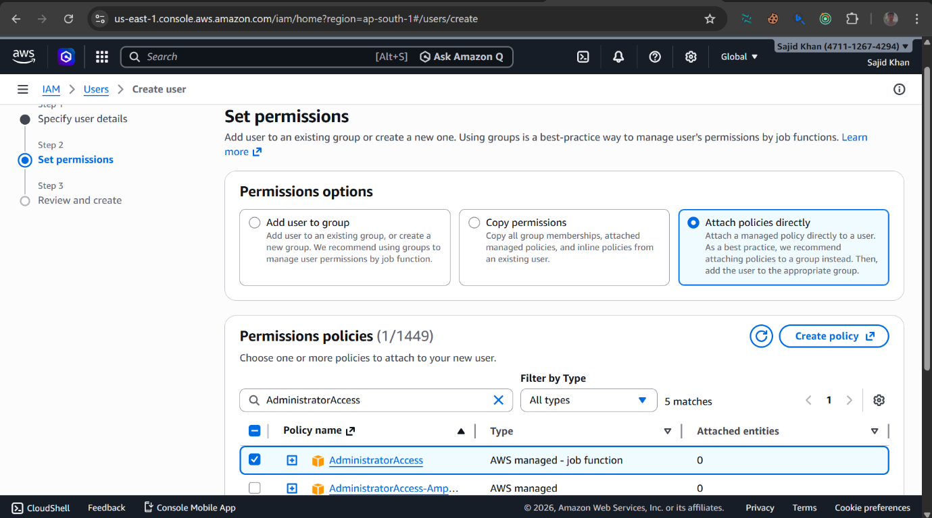
Step 4: Review and Create User
- Review details
- Click Create User
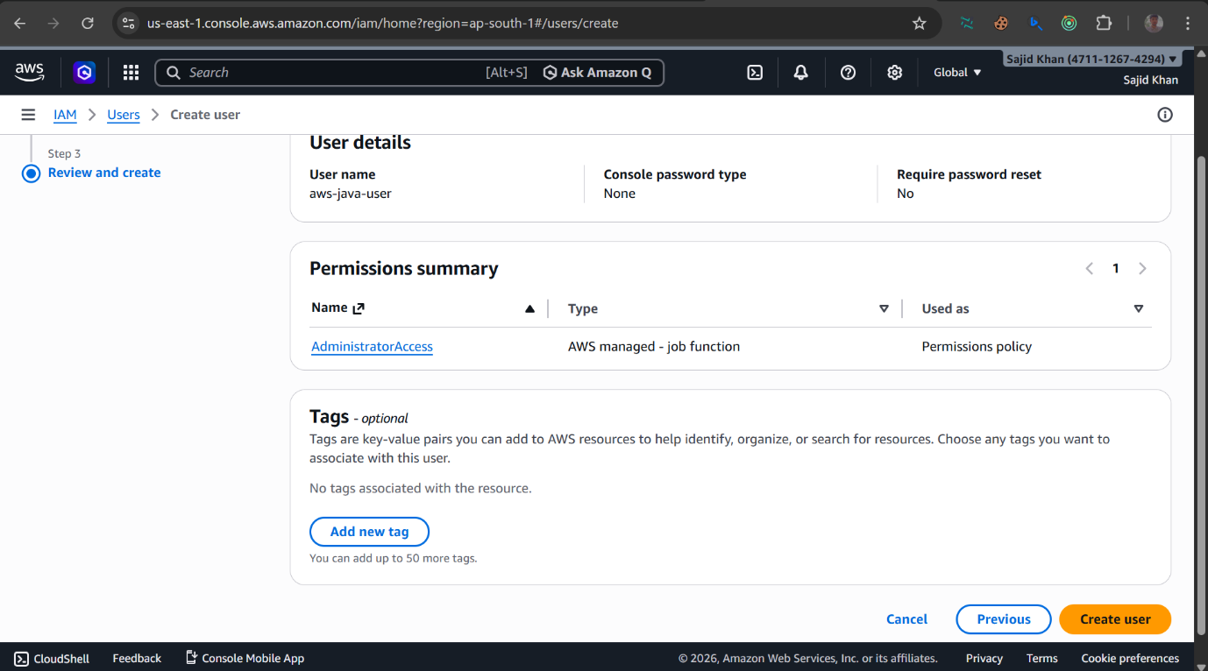
Step 5: User Created Successfully
After creation:
- Click on created user
- Go to Security Credentials
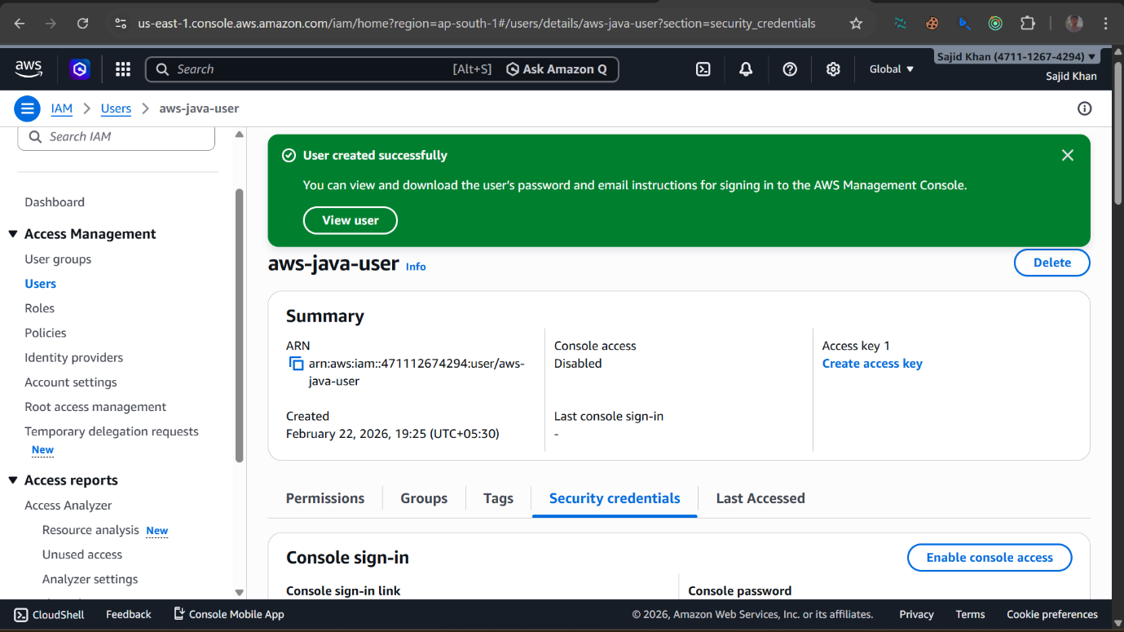
Step 6: Create Access Key
- Scroll to Access Keys
- Click Create Access Key
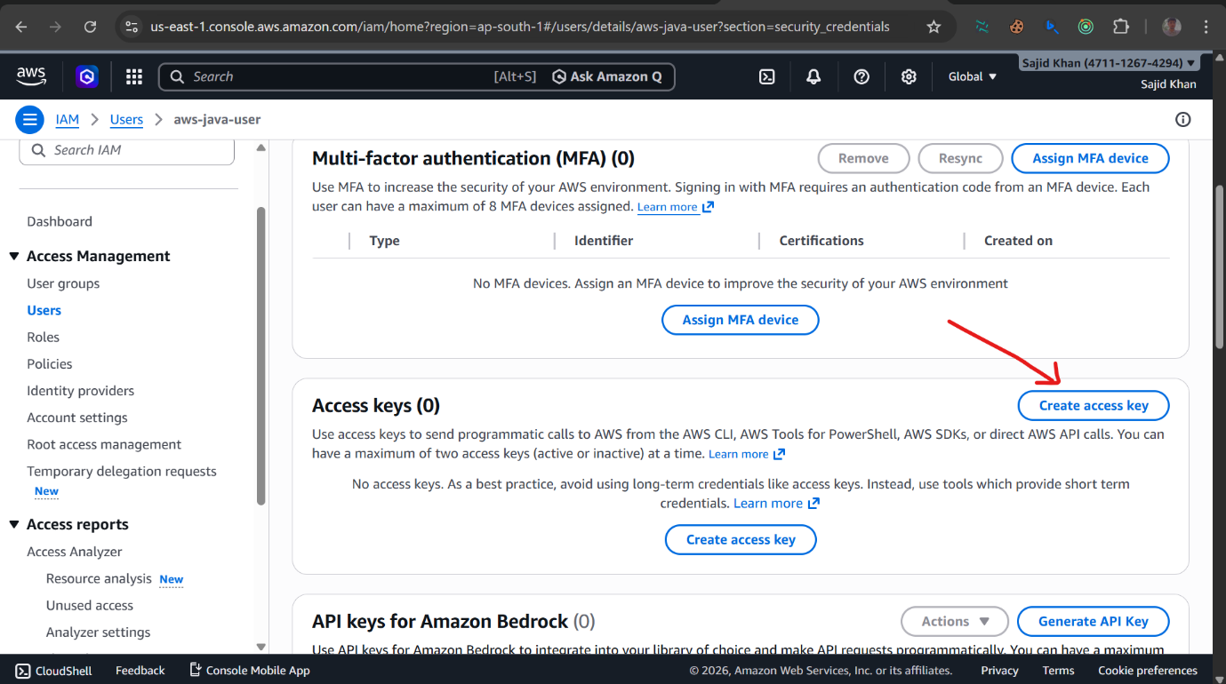

Step 7: Select Use Case
- Select: Command Line Interface (CLI)
- Click Next
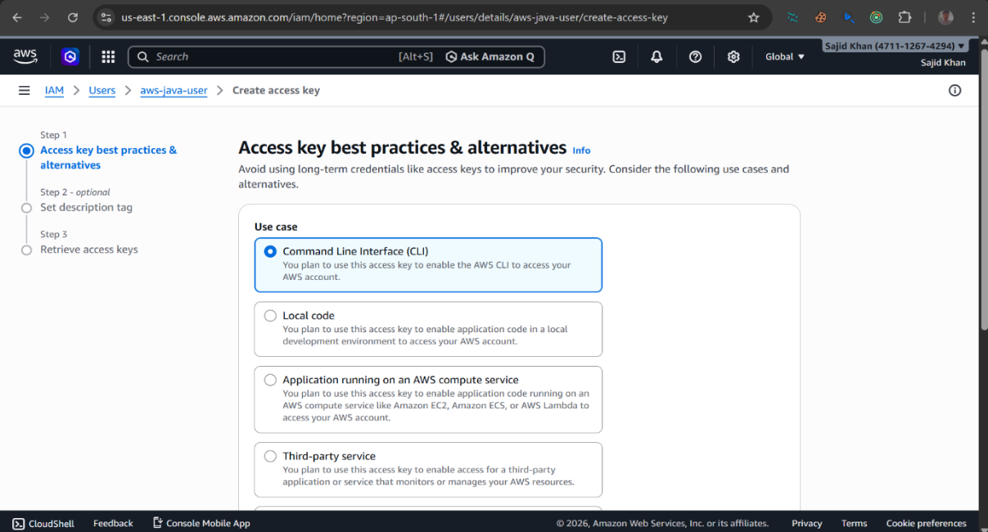
Step 8: Create Access Key
- Click Create Access Key
- Copy Access Key and Copy Secret Access Key OR Click Download .csv file
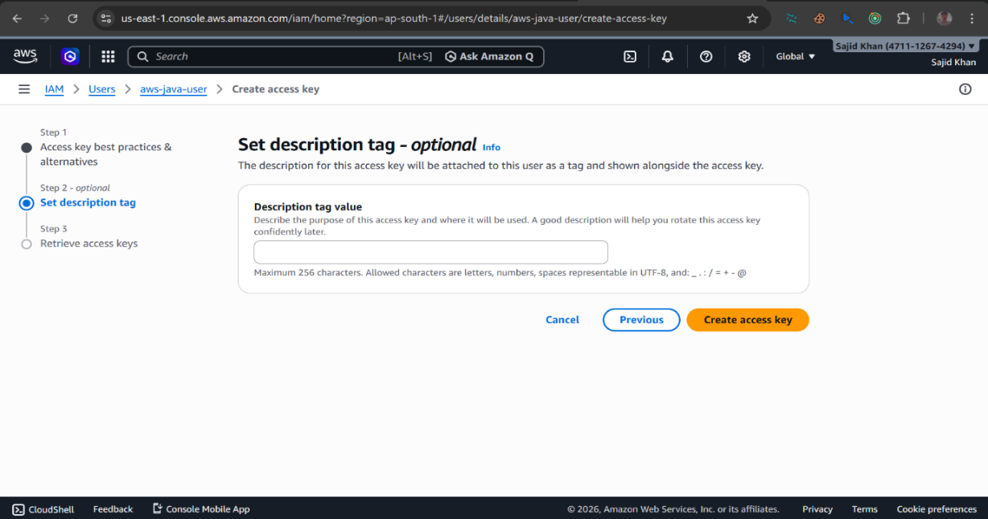
Step 9: Then Download AWSCLI.msi Which is located on WSCC folder
Step 10 : Configure AWS CLI
Open Command Prompt and type: aws configure
Enter:
- Access Key
- Secret Key
- Region: ap-south-1
- Output format: json
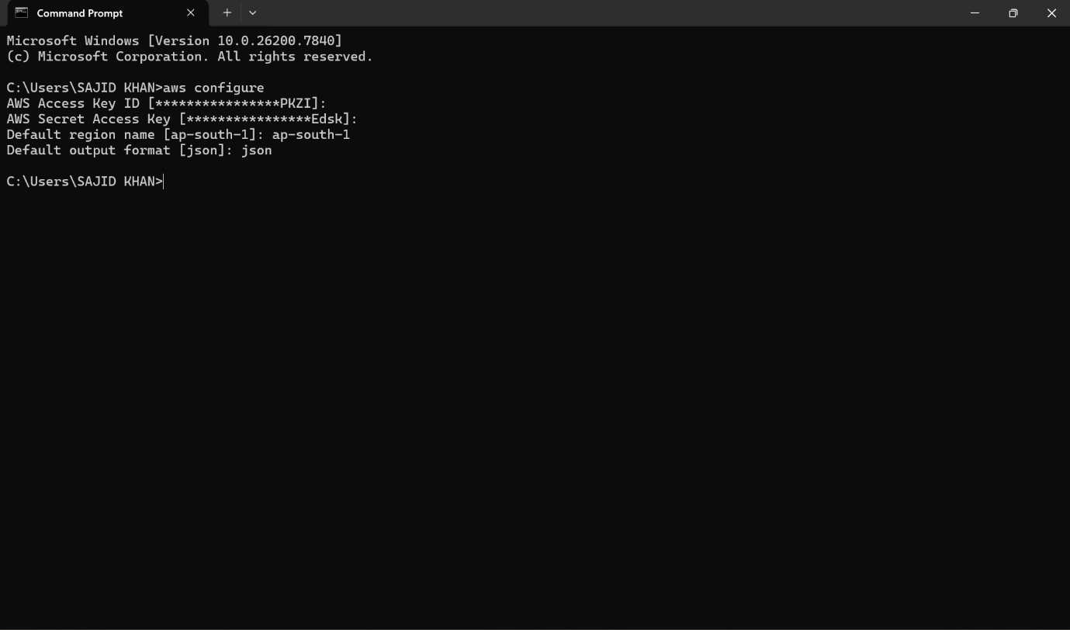
Step 11: NetBeans Project Creation Steps
- Open Apache NetBeans IDE
- Click on File → New Project
- Select Maven → Java Application
- Enter Project Name as AWSWorkFlow
- Click Finish
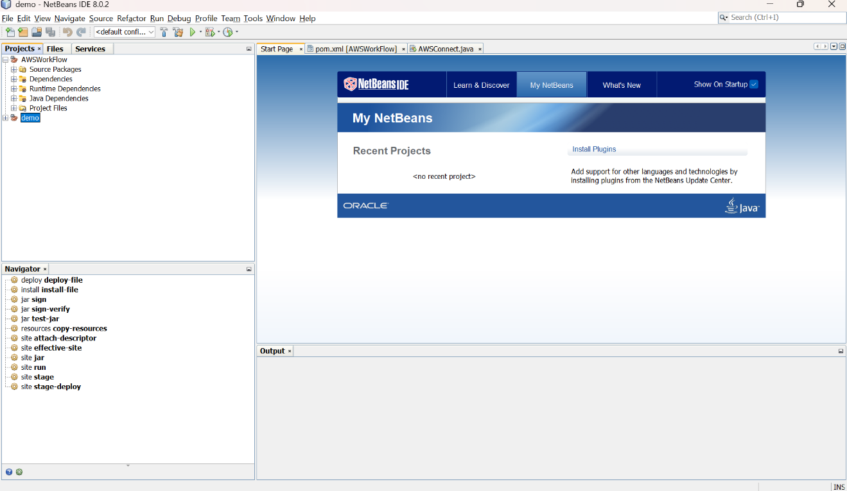
Step 12: Go to Project Files -> pom.xml Configuration
pom.xml :
<?xml version="1.0" encoding="UTF-8"?>
<project xmlns="http://maven.apache.org/POM/4.0.0"
xmlns:xsi="http://www.w3.org/2001/XMLSchema-instance"
xsi:schemaLocation="http://maven.apache.org/POM/4.0.0 http://maven.apache.org/xsd/maven-4.0.0.xsd">
<modelVersion>4.0.0</modelVersion>

<groupId>com.mycompany</groupId>
<artifactId>AWSWorkFlow</artifactId>
<version>1.0-SNAPSHOT</version>
<packaging>jar</packaging>

<properties>
<project.build.sourceEncoding>UTF-8</project.build.sourceEncoding>
<maven.compiler.source>1.8</maven.compiler.source>
<maven.compiler.target>1.8</maven.compiler.target>
</properties>

<repositories>
<repository>
<id>central</id>
<url>https://repo.maven.apache.org/maven2</url>
<snapshots>
<enabled>false</enabled>
</snapshots>
</repository>
</repositories>
<pluginRepositories>
<pluginRepository>
<id>central</id>
<url>https://repo.maven.apache.org/maven2</url>
<snapshots>
<enabled>false</enabled>
</snapshots>
</pluginRepository>
</pluginRepositories>

<dependencies>
<dependency>
<groupId>software.amazon.awssdk</groupId>
<artifactId>swf</artifactId>
<version>2.25.28</version>
</dependency>
<dependency>
<groupId>org.slf4j</groupId>
<artifactId>slf4j-simple</artifactId>
<version>2.0.9</version>
</dependency>
</dependencies>
</project>
Step 13: Create Class, Right Click on AWSWorkFlow project -> New -> Java Class and give the file name AWSConnect and Click finish
Java Implementation Code:
import software.amazon.awssdk.services.swf.SwfClient;
import software.amazon.awssdk.services.swf.model.ListDomainsRequest;
import software.amazon.awssdk.services.swf.model.ListDomainsResponse;
import software.amazon.awssdk.regions.Region;
public class AWSConnect {
public static void main(String[] args) {
SwfClient swf = SwfClient.builder()
.region(Region.AP_SOUTH_1)
.build();
System.out.println("Connected to AWS SWF!");
ListDomainsRequest request = ListDomainsRequest.builder()
.registrationStatus("REGISTERED")
.build();
ListDomainsResponse response = swf.listDomains(request);
System.out.println(response);
}
}

Step 14: Running the Project
Right click on the project in NetBeans and click on Build and Click.
After Success of Build and Click then Right click on the project in NetBeans and click Run.
The application will connect to AWS SWF and display the registered domains.
